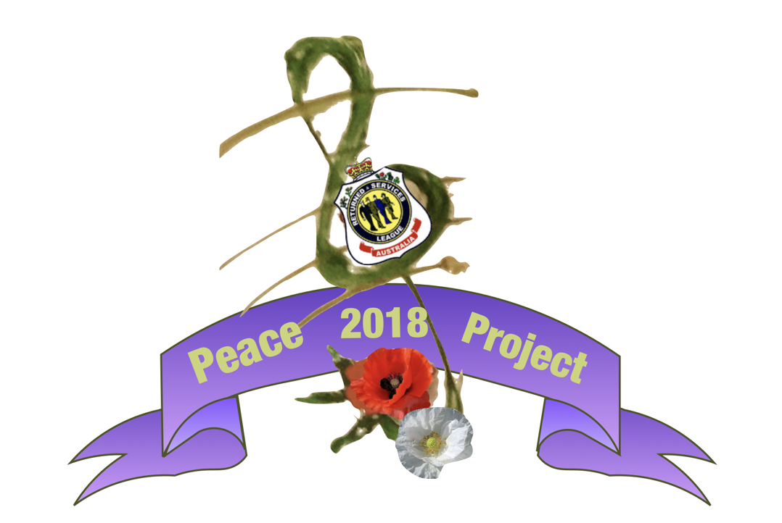
Tuesday, 26 June 2018
Att:
Address
Suburb State Postcode

Dear (Name) ,

I am writing to invite you/your organisation to join us as we participate in the National Peace Project for the Centenary of Armistice this year.

When
Time/s
Where

The Peace Project 2018 is an opportunity to engage as many school aged young people and their families around the nation to -

- Stand for Peace
- Stand for Veterans and their families
- Sing to Remember
- Rethink Remembrance

We are inviting schools, organisations, families, and individuals to stand together with us in peace and sing to remember as we remember the sacrifices that have been made for peace. Let us honour those who have given their lives in service over the last 100 years. Let us remember those who have gone before, honour those who have served and who are still serving and acknowledge all those united by defence service.

This is part of the National Peace Project in which young people from schools, villages, towns and cities across the nation.

- Commemorate the end of the Centenary of Anzac and Great War years
- Celebrate the Centenary of Armistice
- Usher in 2019, the Centenary of the Year of Peace.

What is involved?
Register online: (add your local Peace Project Champion page here)
Learn the 2 Peace Project songs (Online links to rehearsal tracks and music will be sent once you have registered.
We will be in touch with more information as we get closer to the day.

Thanks you for your consideration. Please contact me should you need any further information.

Regards,

(Your Name)

Peace Project Champion for (Town or Area Name)
Email:
Phone:

For more information visit: www.peaceproject.org.au

